**KUBERNETES CLUSTER SETUP (Kubeadm Cluster):**

**Create two Ubuntu machines separately**

* 1. **Master machine: Ubuntu: take t2.medium - 4GB RAM, 2 CPU’s**
  2. **Worker Machine: Ubuntu: take t2.micro - 1 GB RAM, 1 CPU**

**Instances will be created and can be seen like this (Name should be given by us):**

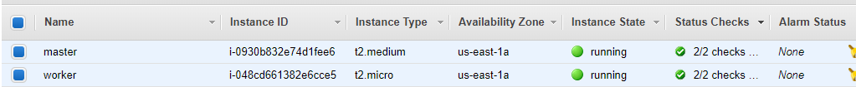

**Connect to both the machines through: key pair.pem - (use git bash or Mobaxterm or putty or any tool to connect)**

**After connecting to the above two ec2 instances, for our convenience, we can set host names for both the machines instead of identifying them through server ip’s.**

**So,**

**--- In t2.medium ec2 instance (i.e. in master server), give this command:**

**# sudo –i**

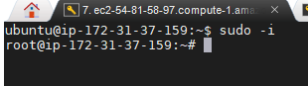

**# sudohostnamectl set-hostname master**

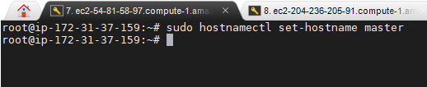

**# sudo –i**

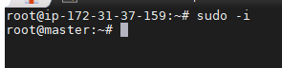

**--- In t2.micro ec2 instance (i.e. in worker server), give this command:**

**# sudo –i**

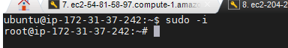

**# sudohostnamectl set-hostname worker**

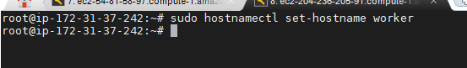

**# sudo –i**

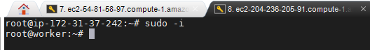

**EXECUTE BELOW COMMANDS IN BOTH MASTER AND WORKER MACHINES SIMULTANEOUSLY:**

**(Note: we have to execute these commands in both master and worker)**

**#** sudo apt-get update

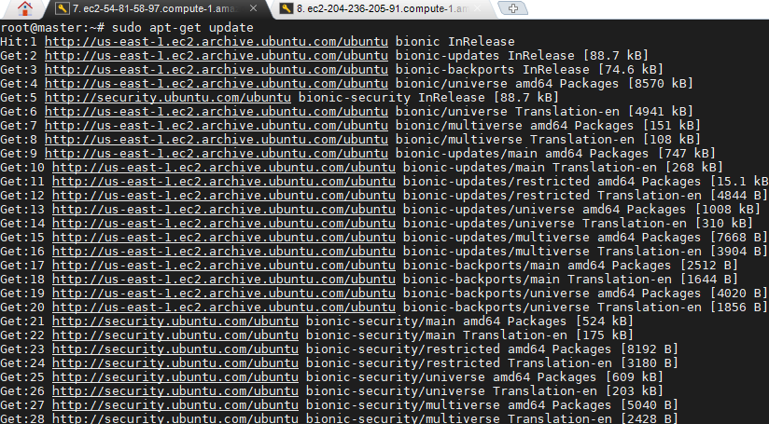

# apt-get update && apt-get install -y apt-transport-https curl

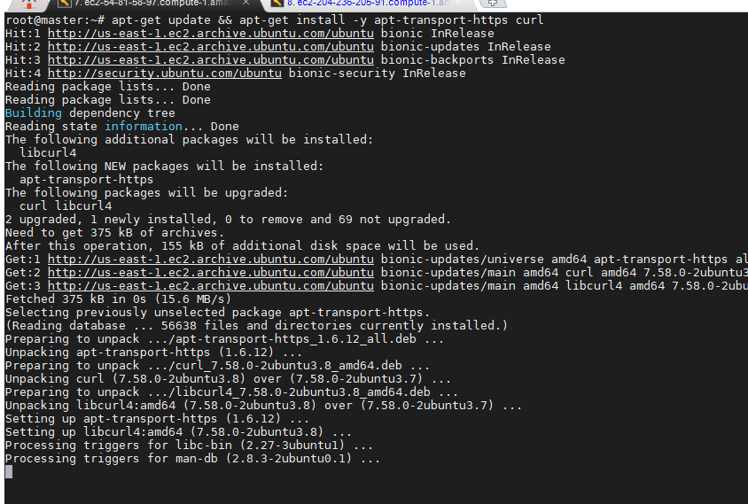

# curl -s https://packages.cloud.google.com/apt/doc/apt-key.gpg | apt-key add -

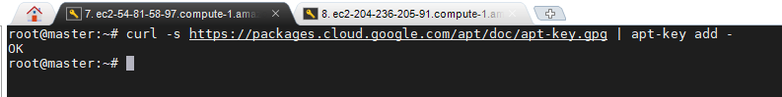

# cat<<EOF >/etc/apt/sources.list.d/kubernetes.list

deb https://apt.kubernetes.io/ kubernetes-xenial main

EOF

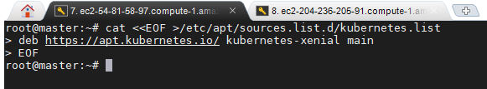

# apt-get update

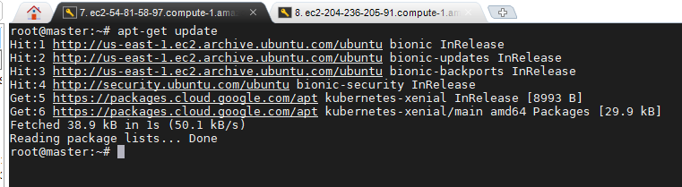

# swapoff -a

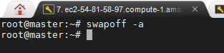

# modprobe br_netfilter

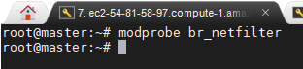

# sysctl -p

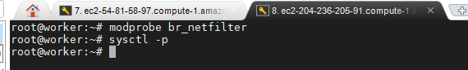

# sudo sysctl net.bridge.bridge-nf-call-iptables=1



# apt-get install docker.io -y

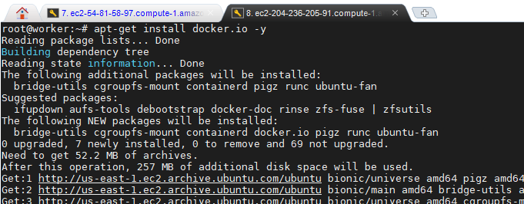

# usermod -a -G docker ubuntu

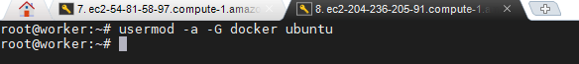

# sudo systemctl start docker



# sudo systemctl enable docker

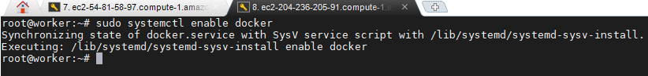

# docker --version

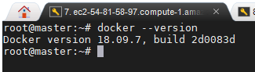

# apt-get install -y kubelet kubeadm kubectl kubernetes-cni

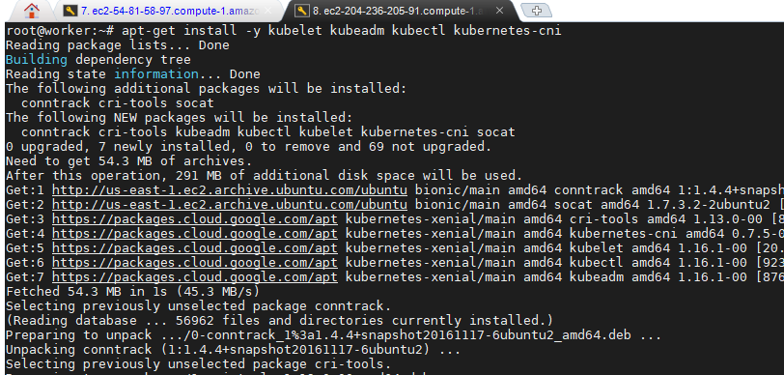

# systemctl daemon-reload

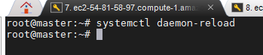

# systemctl start kubelet

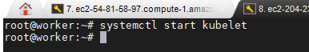

# systemctl enable kubelet.service

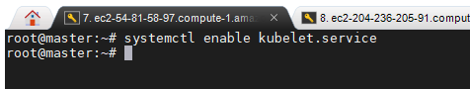

**EXECUTE THESE COMMANDS ONLY IN MASTER MACHINE**

# kubeadm init

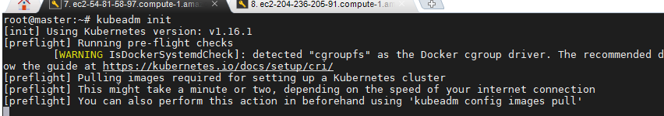

**Note: After initialized kubeadm, copy the “kubeadm join” command and paste it in notepad for pasting it in workers machine to join the workers**

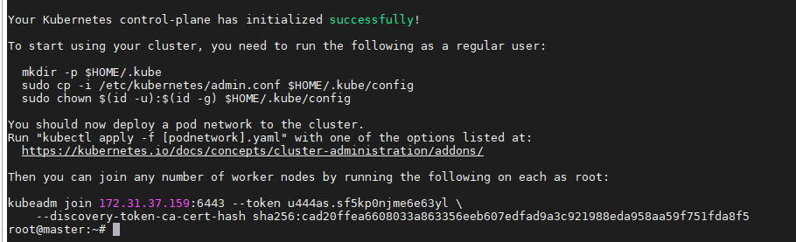

**Copy this:**



**Paste it in a notepad:**

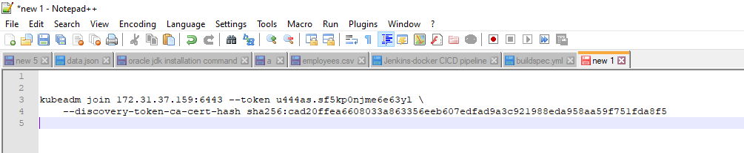

# exit

(exit from root user & execute as normal user (i.e. as a ubuntu user))

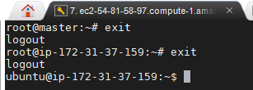

------------------------------------------------------------------------------------------------

# mkdir -p $HOME/.kube

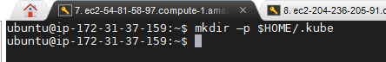

# sudocp -i /etc/kubernetes/admin.conf $HOME/.kube/config

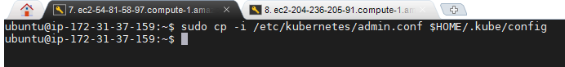

# sudochown $(id -u):$(id -g) $HOME/.kube/config

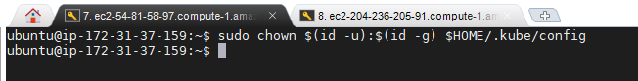

**[NOTE: Above 3 commands will be performed correctly, only after we give “kubeadm init”]**

**Now, give the below command also in Master server only:**

**#** kubectl apply -f [https://cloud.weave.works/k8s/net?k8s-version=**$(**kubectl version | base64 | tr -d '\n'**)**](https://cloud.weave.works/k8s/net?k8s-version=$(kubectl%20version%20|%20base64%20|%20tr%20-d%20'\n'))

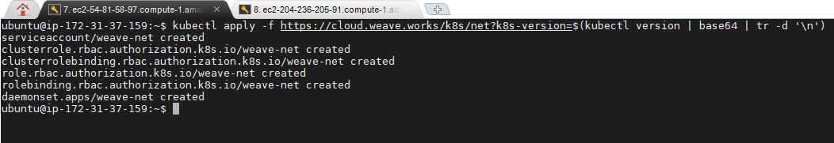

**#** kubectl get nodes

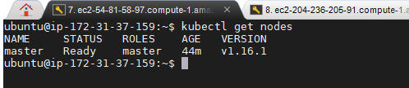

**TO JOIN WORKER NODES TO MASTER:**

Run the below command only on workers nodes and this command is available when we run “kubeadm init” in master machine. (Note: we have to run the copied and pasted command in your notepad, not the exact one as shown below….below one is just an example only, don’t use it)

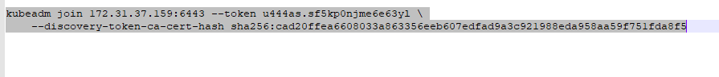



This will not run until you allow the port number 6443 in security groups of your ec2-instances. So, allow the port number 6443 inside security groups of both master and worker nodes:

Select your ec2-instance – Description (at the bottom) – Security groups – click on launch-wizard

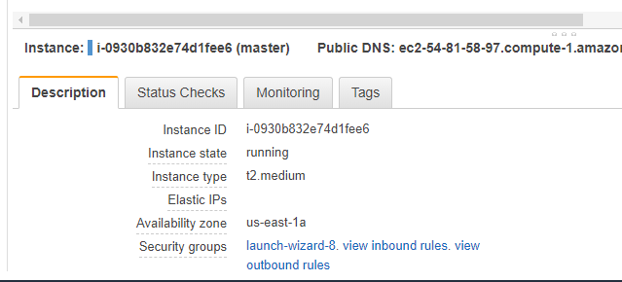

Select inbound: Edit :

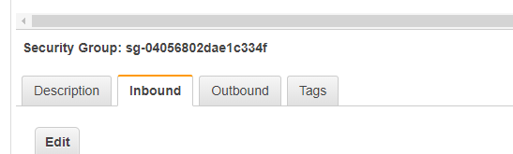

Click on Add rule:

* + Add port number 6443 as shown below (in both machines):

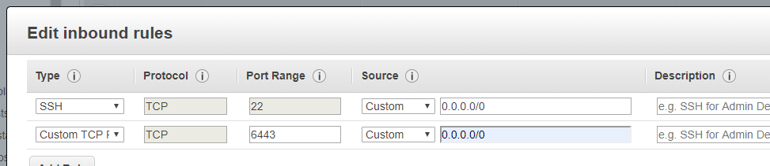

Now, it will run and you can see the worker node has joined the cluster:

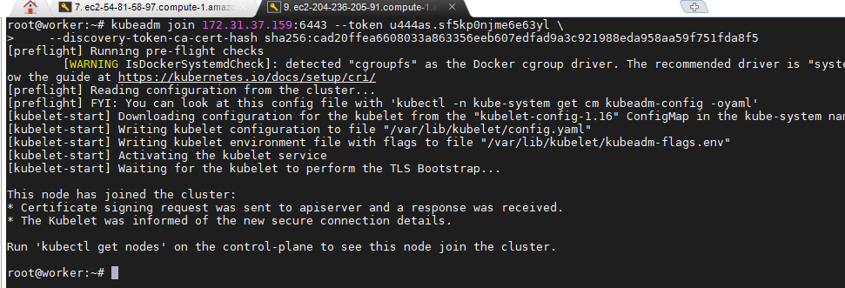

Now, in master machine, run this command:

# kubectl get nodes

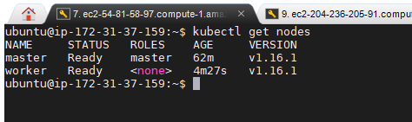

*********************Kubeadm cluster setup completed************************